Laboratorio 5

Integrantes

1.- Jordy Castro Trigoso PT71196741

2.- LUIS MANUEL JESUS RAMIREZ JERI PT47597144

3.- RUBEN BARRENECHEA PT71428946

4.- JHON GUZMAN PT74058076

5.- LEONARDO OLGADO PT72227219

6.- Michael Junior Villarreal Lopez PT74136536

7.- Kevin Arditto PT73676878

8.- Johan Orozco PT75899105

Convierta de decimal a binario

224

123

64

|  |  |  |  |  |  |  |  |  |
| --- | --- | --- | --- | --- | --- | --- | --- | --- |
| **128** | **64** | **32** | **16** | **8** | **4** | **2** | **1** | **Decimal** |
| 1 | 1 | 1 | 0 | 0 | 0 | 0 | 0 | 224 |
| 0 | 1 | 1 | 1 | 1 | 0 | 1 | 1 | 123 |
| 0 | 1 | 0 | 0 | 0 | 0 | 0 | 0 | 64 |

Convierta de binario a decimal

10111011

11000000

10101011

|  |  |  |  |  |  |  |  |  |
| --- | --- | --- | --- | --- | --- | --- | --- | --- |
| **128** | **64** | **32** | **16** | **8** | **4** | **2** | **1** |  |
| 1 | 0 | 1 | 1 | 1 | 0 | 1 | 1 | 187 |
| 1 | 1 | 0 | 0 | 0 | 0 | 0 | 0 | 192 |
| 1 | 0 | 1 | 0 | 1 | 0 | 1 | 1 | 171 |

Se tiene la siguiente dirección IP 192.168.20.60/30 . Cuál es la dirección de red y broadcast

|  |  |  |  |  |  |  |  |
| --- | --- | --- | --- | --- | --- | --- | --- |
| **128** | **64** | **32** | **16** | **8** | **4** | **2** | **1** |
| 0 | 0 | 1 | 1 | 1 | 1 | 0 | 0 |
| 1 | 1 | 1 | 1 | 1 | 1 | 0 | 0 |
| 0 | 0 | 32 | 16 | 8 | 4 | 0 | 0 |
| RED | 192 | 168 | 20 | 60 |  |  |  |
| FIM | 60 | + | 3 | = | 63 |  |  |
| BROAD |  |  |  |  |  |  |  |
| 192 | 168 | 20 | = | 63 |  |  |  |
|  |  |  |  |  |  |  |  |

Se tiene la siguiente dirección IP 192.168.100.50/27 . Cuál es la dirección de red y broadcast

|  |  |  |  |  |  |  |  |
| --- | --- | --- | --- | --- | --- | --- | --- |
| **128** | **64** | **32** | **16** | **8** | **4** | **2** | **1** |
| 0 | 0 | 1 | 1 | 0 | 0 | 1 | 0 |
| 1 | 1 | 1 | 0 | 0 | 0 | 0 | 0 |
|  |  | 32 |  |  |  |  |  |

INICIO 32 32-1=31

RED 192.168.100.32 32+31=63

BROADCAST 192.168.100.63

------------------------------------------------------------------------------------------------------------------------

**¿Cuál es el formato comprimido de la dirección IPv6 fe80:0001:000b:0000:0220:0b2e:f0e0:0009?**

**Un administrador de red está agregando una nueva LAN a una sucursal. La nueva LAN debe admitir 30 dispositivos conectados. ¿Cuál es la máscara de red más pequeña que el administrador de red puede usar para la nueva red?**

|  |  |  |  |  |  |  |  |
| --- | --- | --- | --- | --- | --- | --- | --- |
| **128** | **64** | **32** | **16** | **8** | **4** | **2** | **1** |
|  |  |  |  |  |  |  |  |

145. Un administrador de red está agregando una nueva LAN a una sucursal. La nueva LAN debe admitir 25 dispositivos conectados. ¿Cuál es la máscara de red más pequeña que el administrador de red puede usar para la nueva red?

255.255.255.240

255.255.255.128

255.255.255.224

255.255.255.192

|  |  |  |  |  |  |  |  |
| --- | --- | --- | --- | --- | --- | --- | --- |
| **128** | **64** | **32** | **16** | **8** | **4** | **2** | **1** |
|  |  |  |  |  |  |  |  |

146. Un administrador de red está agregando una nueva LAN a una sucursal. La nueva LAN debe admitir 10 dispositivos conectados. ¿Cuál es la máscara de red más pequeña que el administrador de red puede usar para la nueva red?

255.255.255.240

255.255.255.128

255.255.255.224

255.255.255.192

|  |  |  |  |  |  |  |  |
| --- | --- | --- | --- | --- | --- | --- | --- |
| **128** | **64** | **32** | **16** | **8** | **4** | **2** | **1** |
|  |  |  |  |  |  |  |  |

**154. Consulte la ilustración. Coloque la dirección de red, broadcast**

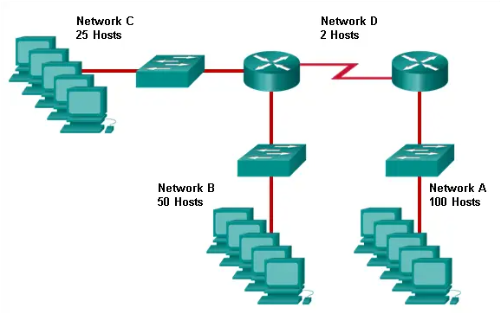

|  |  |  |  |  |  |  |  |  |  |  |
| --- | --- | --- | --- | --- | --- | --- | --- | --- | --- | --- |
| **128** | **64** | | **32** | **16** | | **8** | **4** | **2** | **1** | |
|  |  | |  |  | |  |  |  |  | |
|  |  | |  |  | |  |  |  |  | |
|  |  | |  |  | |  |  |  |  | |
|  |  | |  |  | |  |  |  |  | |
| host | | Red | | |  | | |  | | Broadcast | |  |
| 100 | | 192.168.0.0 | | |  | | |  | |  | |  |
| 50 | |  | | |  | | |  | |  | |  |
| 25 | |  | | |  | | |  | |  | |  |
| 2 | |  | | |  | | |  | |  | |  |